The Efficacy of iPad Math Apps versus Hands-On Math

in the Kindergarten Classroom

Kathy Moorehead

Touro University, California

ED790 New Literacies

Dr. James Brown

January, 2014

**The Efficacy of iPad Math Apps versus Hands-On Math in the Kindergarten Classroom**

**Research Question**

1. Which is more effective at creating a deeper understanding of core mathematical concepts at the kindergarten level, working with math manipulatives or with apps on an iPad?

**Introduction and Statement of the Problem**

The research that supports the use of hands-on manipulatives to help build core mathematical concepts at an early age is long and well-established. (Clements, 1999). But with the rise in the use of technology in the classroom and the implementation of iPads as a teaching tool at the kindergarten level, I was curious to see if time spent working on iPad math apps was *as* effective as time spent working with math manipulatives. This was of particular interest to me as my practice was changing both in terms of direct instruction and in allocating math exploration time that previously would have been spent hands-on to include working with iPads.

“Watch the pennies and the dollars will take care of themselves” is a well-known saying. A teacher might say, “Watch the instructional minutes and the learning will take care of itself.” Experienced teachers know that for every instructional choice we make there is one or many that we don’t. Our decisions about how to best use our instructional minutes should be based on research rather than “gut intuition”, and that was the impetus for beginning this action research study.

The purpose of this study was to compare and analyze whether one of these two supporting strategies would lead to greater understanding of core mathematical concepts than the other. Clearly, these are just two of many supporting strategies such as math journals, problem-based learning, project-based learning, and computer based programs such as Mobymax and Jiji math. (Mobymax, 2014) (MIND Institute Research, 2013) Teachers need to differentiate instruction based on different learners’ needs, but comparing methods for efficacy may still provide valuable information for the teacher.

As iPad technology is new, and iPad implementation in the classroom is even newer, the research is all relatively recent, but it is definitely beginning to come in. There have not been any long-term studies, but as more and more “new” technology reaches the classroom, we will increasingly need to rely on the short-term studies to make these types of decisions.

I recently attended the 2014 Google in Education Summit in Napa, CA, and Molly Schroeder, the keynote speaker at the closing session, said, “Just as in business, educators today must be working in Beta.” We clearly can’t wait for long-term studies on iPads or any other potentially useful technologies before we begin implementing them to see *how* they might be useful in our classrooms. Action Research in the classroom will become more significant as the window on the introduction of new technologies continues to shrink.

But the problem still exists as to how we will best spend our educational dollars. Where will we get the best bang-for-the-buck in educational spending? Apple iPads are not cheap. They cost about $500 per unit. In a typical classroom of twenty kindergarten students, the initial investment would be at least $10,000. This could be reduced by sharing a bank of iPads between one or more classes, but this raises problems as iPads were not designed to be shared. They are an “end user” technology and are meant to be used 1:1.

Dr.Marilyn Burns is the author of several books on teaching math and has her own website. (Math Solutions, 2014) A popular Marilyn Burns math manipulatives kit for use with nonfiction book-set would cost about $340 for one classroom set. Imagine how many hands-on math manipulatives you could get with $10,000! What is the best use of our educational dollars?

**Review of Related Literature**

**Introduction**

Apple iPads debuted in April of 2010. Since then, sales to schools for educational purposes have continued to grow. According to TechnoBuffalo, there are at least eight million out there:

(Apple) confirmed to TechCrunch in a separate statement that it has sold more than 8 million iPads to schools and other educational facilities around the globe…more than half of those sales, 4.5 million units, were sold to schools in the United States. (Haselton, 2013)

It is no doubt that the number of iPads in schools will continue to grow as more schools look for ways not only to implement iPad use but to get their students to a 1:1 ratio. One study done by Abilene Christian University (ACU) eventually concluded that they simply could not roll out iPads in a way that they were not intended to be used. They wanted to keep their iPads, but simply could not afford the capital investment at the time. (Cullen & Gasparini, 2012) They *had* found the iPads to be effective. In the ACU study, students who used an iPad annotation app showed a 25% advantage when questioned over students who used traditional textbooks with paper and pencil to make annotations. (Cullen and Gasparini, 2012)

Another study of the effectiveness of iPads was conducted using the game Motion Math with fourth graders to teach fractions. In that study, “students’ fractions test scores improved an average of over 15% after playing Motion Math for 20 min daily over a 5-day period, representing a significant increase compared to a control group.” (Riconscente, 2013)

A study was also done which looked at the use of an iPad text for support with algebra at a middle school in Riverside, California. Houghton Mifflin Harcourt and Apple conducted the study from the spring of 2010 to 2011 and found that, “20% more students (78% compared to 59%) scored 'Proficient' or 'Advanced' in subject comprehension when using tablets rather than paper textbook counterparts.” (Bonnington, 2012)

Further research was done at

Not all studies have shown *significant* results, however. One study was conducted on kindergarteners in Auburn, Maine to examine the efficacy of iPads used for literacy support. In a randomized control trial, ten different testing measures were examined and only one proved to favor the use of iPad apps. Mike Muir of the Auburn School District described the results of the study in his choice of headline in his blog posting: “Confirmed: iPads extend a teachers impact on kindergarten literacy.” (Muir, 2012) Researcher Justin Reich retorted with the headline he would use to announce the results as, “Ipads modestly increased kindergarten literacy scores in 1 out of 10 measures tested.” (Reich, 2012)

The Department of Education and Early Childhood Development for Victoria, Australia did field trials on the use of iPads in nine schools, but most of the results of the field trial speak to increased motivation and engagement, both for the students and for the teachers. The only results driven data that spoke to proficiency appeared in the form of teacher perceptions rather than from quantitative data:

83% of primary teachers and 67% of special school teachers thought that using the iPad had improved students’ literacy outcomes vs. 16% in secondary schools (I & J Management Services, 2011)

It may be more difficult to quantify literary proficiency as opposed to mathematical proficiency, but that is the type of data we need to understand the efficacy of using iPad apps in the classroom as opposed to more traditional teaching strategies.

Similarly, another iPad study conducted in Kent, England at the Longfield Academy reported increased efficacy with the use of iPad apps, but the data was only qualitative and not quantitative. Findings again spoke to motivation as reflected in teacher and student surveys, and when achievement was mentioned, it took the form of teacher opinion of increased achievement:

The study used surveys to assess the impact of iPad use on motivation, quality of work, achievement, collaboration, and other factors. Among the findings:

* 77% of faculty respondents felt that student achievement appeared to have risen since the introduction of the iPad
* 73% of students and 67% of staff felt that the iPad helped students improve the quality of their work
* 69% of students that completed the survey felt that using the iPad was motivating and that they worked better with it than without it
* 60% of faculty thought that students were more motivated by lessons that incorporate the iPad than those that did not (Walsh, 2012))

But not everyone has jumped onto the iPad bandwagon:

“There is very little evidence that kids learn more, faster or better by using these machines,” said Larry Cuban, a professor emeritus of education at Stanford University, who believes that the money would be better spent to recruit, train and retain teachers. “IPads are marvelous tools to engage kids, but then the novelty wears off and you get into hard-core issues of teaching and learning.”(Hu, 2011)

This action research project did not look at whether iPads increased student or teacher motivation. This project looked at whether playing an iPad app led to greater understanding as compared to more traditional teaching methods. Similar questions were asked when laptops for students was the newest technology and schools were making large capital investments in laptops for students in the hopes that these investments would help raise student test scores:

Many school administrators and teachers say laptops in the classroom have motivated even reluctant students to learn, resulting in higher attendance and lower detention and dropout rates. But it is less clear whether one-to-one computing has improved academic performance — as measured through standardized test scores and grades — because the programs are still new, and most schools have lacked the money and resources to evaluate them rigorously. In one of the largest ongoing studies, the Texas Center for Educational Research, a nonprofit group, has so far found no overall difference on state test scores between 21 middle schools where students received laptops in 2004, and 21 schools where they did not, though some data suggest that high-achieving students with laptops may perform better in math than their counterparts without. When six of the schools in the study that do not have laptops were given the option of getting them this year, they opted against. (Hu, 2007)

**Research Methods**

**Design:**

This study was designed to investigate the effectiveness of iPad apps as compared with the more traditionalteaching strategy of using hands-on activities or math manipulatives. Kindergarten students in a classroom of ten students were divided into two groups of five and were introduced to new math concepts, or games, with either the use of traditional hands-on methods or use of an iPad math app.

Each lesson was part of an Everyday Math Program that was adopted at our school and appropriate to the kindergarten level. (Everyday Math, 2014) Each lesson was an introductory lesson of a concept that had not previously been taught. Pre-tests were given to check for prior knowledge of the concept, vocabulary or subject. Students were divided into two groups of five students each. Both groups were given direct instruction in a math concept and followed the traditional model of “I-do, We-do, You-do,” whether working with apps or with a hands-on activity. (Maiers, 2009) Student archival documents such as student drawings, pre-tests and post-tests were collected along the way.

A “mixed methods approach, combining aspects of both qualitative and quantitative research” was used, as described in Action Research: Teachers as Researchers in the Classroom, by Craig Mertler. (Mertler, 2009, p.11). The qualitative observations of students during pre-tests, post-tests, and seatwork were captured on film when possible, and annotated by the researcher in a video voice over to serve as field notes. The quantitative method was used in analyzing the pre-, mid- and post-test and generating a graph of results.

The kindergarten classroom sampled was in a rural community in a small school with just over one hundred students in kindergarten through eighth grade. There was only one teacher at each grade level and most classes were combination classes. The kindergarten class sampled had only ten students. A typical kindergarten classroom would have twenty students. (United States, National Center for Education Statistics, Institute of Education Services, 1993)

As the sample size of students was not representative of the typical kindergarten classroom size, the original research design was to get as many data points as possible in a very limited amount of time. Originally, the plan was to teach all ten students one distinct math concept using iPads and the next distinct math concept using hands-on strategies, but the design plan was changed upon reflection. It was thought that there would be no way to compare efficacy using this method, as one concept might be harder than the other. For example, symmetry might be inherently more complex than learning how to play Mancala, or vice versa.

Another part of the original research design that proved to be extremely problematic was the implementation of “post-tests” after merely one exposure to a new concept. Giving pre-tests to check for prior knowledge was easy and familiar, but giving “post-tests” so early, after just one lesson, felt very uncomfortable. The time constraints were a factor in testing students in a way that would not normally be done. In “real life”, students would never be given just one lesson and then tested for proficiency! In a small classroom of ten students who all “see each other’s work” and have access to the iPads, this seemed to be the only way to design the research so that the two methods could be isolated as effective or not. There was also a concern about the students accessing the iPad apps both in the after school program and at home, which was out of the researcher’s control, so the design was to complete each lesson in one day to ensure that the results would be considered reliable.

The review of the relevant literature continued even as the implementation of the action plan began. A study on the efficacy of using an iPad math app at the elementary level was found that looked at just one math app called Motion Math which dealt with fractions. (Riconsente, 2012). The design method this project followed was called “the repeated measures crossover design method.” This method compared two groups of students over a longer period of time before post-testing. This research design method had the added benefit of including a control group but also switching control groups and re-testing the entire class.

A decision was made to re-design the parameters of the research to hopefully improve the process. Research was limited to just one math concept, learning the game of Mancala over a week’s time. The help of an aide was enlisted to enable the separation of the two groups of five children as direct instruction was given followed by seatwork time with either the app or the real board game. Mertler tells us that the action research process is a spiraling process. (Mertler, 2009, p.13) The decision was made to continue on with the time left with just one more math concept studied over several days.

**Materials:**

The math apps used included Symmetry Lab (Bradford, 2013) and Mancala (Byterun, 2013). Hands-on lessons included creating butterfly drawings with symmetrical wings and learning to play the game Mancala on a real 3D-game board.

**Artifacts:**

The artifacts collected include copies of the form used for pre- and post-tests, a teacher test script, and a student work sample. (See appendix A-D)

**Procedures:**

Phase 1:

The original design was to teach five different math concepts to all ten students using iPad apps as supports and five more math concepts using traditional math manipulatives to all ten students and then compare the results. The procedures in this phase were never implemented as it was thought that there would be no way to compare efficacy using this method, as one concept might be inherently harder than the other. Without a control group, results might not be reliable.

Phase 2:

In this phase a control group was created, but only one math concept from this phase was taught. Two lessons on the concept of symmetry were taught to two groups of five children each. Groupings were chosen by random selection using names on Popsicle sticks. One group was taught using the Symmetry Lab app (Bradford, 2013) and the other group was taught with a hands-on lesson which included creating butterfly drawings with symmetrical wing patterns. All ten children were pre-tested to check for prior knowledge of the concept of symmetry. None of the children knew what it was; there was a blank slate. Pre-testing was done on the first day, and direct instruction was done on the following day. Post-testing was done on the third day. This research was abandoned for reasons mentioned in the design description above. The time constraints were a factor in testing students in a way that would not normally be done and results were considered unreliable.

One procedural problem was revealed when the video tape footage for pre- and post-testing on symmetry was reviewed. As much as there had been a conscious effort made to say the same thing to each student as the directions were read for the pre- and post-tests, the video clearly showed that the prompts were “all over the board” in terms of consistency. The researcher resolved to have a script written out for future action research projects.

Similarly, another procedural problem was encountered during the pre- and post-testing phase for symmetry which had to do with prompting. The pre- and post-tests for symmetry were identical. The test consisted of a row of five graphic images of rabbits. (See appendix A and B) Two were symmetrical and three were not. The oral directions were to circle the rabbits that showed symmetry. When the students appeared to have stopped circling, they were asked if they were done. This was attempted very matter-of-factly, but ended up having the effect of “leading the witness.” Body language from a few students seemed to scream, “She must want me to circle more rabbits; I must not be done yet!” The researcher noted that one of the students seemed to know what symmetry was and only circled the asymmetrical rabbit after he heard this prompt and inferred that he *must not be done*. In this case, the prompting was consistent to each student, but it proved to be problematic in a population that simply cannot read test prompts on their own. The age and suggestibility of the students seemed to be a factor.

Yet another procedural problem occurred when one student saw the overturned answer page in the post-test of a previous student. Students were tested one-on-one, and this was just a mistake. Whether it had an effect on the second student’s answers is impossible to know. Once again, a resolution was made to improve procedural methods and make sure that all previous testing materials were out of view.

For the reasons listed above, the results of this phase of the testing were considered to be unreliable and a third phase of action research with a better design plan and better procedural methods was initiated.

Phase 3: Mancala

This phase of research lasted a week. Students were again divided into two groups of five students each by random selection using names on Popsicle sticks. The crossover design method was used. The Manipulative Group 1 was introduced to the game of Mancala with a real game board while the iPad app Group 1 was introduced to the game with an iPad app. Students were given pre-tests, direct instruction in the app or game, practice time, and then a mid-test to assess their understanding.

The traditional lesson plan design of “I-do, We-do, You-do” was used. (Maiers, 2009) The manipulatives group 1 worked with a classroom aide on an unrelated project while the teacher gave direct instruction to the iPad group 1 on how to play the game Mancala on an iPad app. The app was mirrored onto an Apple TV projector. The rules of the game were modeled as the teacher played against the computer using the app and vocalizing her decisions and strategy moves. Next, students played against the iPad app while the teacher observed, offered more instruction, and made strategy suggestions. Finally, students had two twenty-minute sessions of practice time to play on their own.

The Manipulatives Group 1 was given direct instruction in the traditional board game of Mancala with the same “I-do, We-do, You-do” format. They were shown a hand-carved Mancala board that was brought back from Africa. Kids were allowed to touch the wood and notice the four face carvings on the outside of the board. Next, they were shown a YouTube video tutorial for the “I-do” portion of the lesson on how to play the board game. (St.George, 2008) The “We-do” part of the lesson consisted of a volunteer playing against the classroom teacher while the other children watched, commented, and asked questions. Then two students were selected to model play as the other three looked on. Finally two different students took their place to continue play as the other three now looked on.

After direct instruction, children chose partners and began to play. The teacher provided further instruction to the partnerships as they played. Manipulatives group 1 received two twenty-minute practice sessions to play on their own with teacher check-ins and further instruction when needed. Partners were switched to pair stronger students with weaker ones based on instructor observations.

Each grouping of five students had been given two twenty-minute sessions of practice time each on *either* the app *or* the board game before they were given a mid-test to see what they understood about the game Mancala. The mid-test was given one-on-one on the real Mancala board for all ten students. Students were asked to set up the board and to begin play and then the researcher noted what they knew in the field note video log. Observations focused on six signs of learning: (1) whether they knew the name of the game, (2) whether they could set up the game board, (3) whether they could play in a counter-clockwise direction, (4) whether they knew to pick up all the beads in one cup and drop only one bead into sequential cups as they played, (5) whether they understood the rules for turn-taking, and (6) whether they showed any evidence of employing strategy.

Using the crossover design method, the groups were now switched. The manipulatives group 1 was given the chance to learn the Mancala iPad app. They were given the same direct instruction as the iPad group 1 received and also allowed two twenty-minute practice sessions with teacher check-ins and support when needed. Once again, seating changes were made to put stronger app players next to weaker ones based on instructor observations. Finally, the iPad app group 1 was given direct instruction on the real board game and the same teacher support and practice sessions as the manipulatives group 1 had received.

The post-test was given on the real Mancala board for all ten students. The post-test was identical to the mid-test. It was conducted one-on-one with each student and the same six factors of understanding were recorded on the video log.

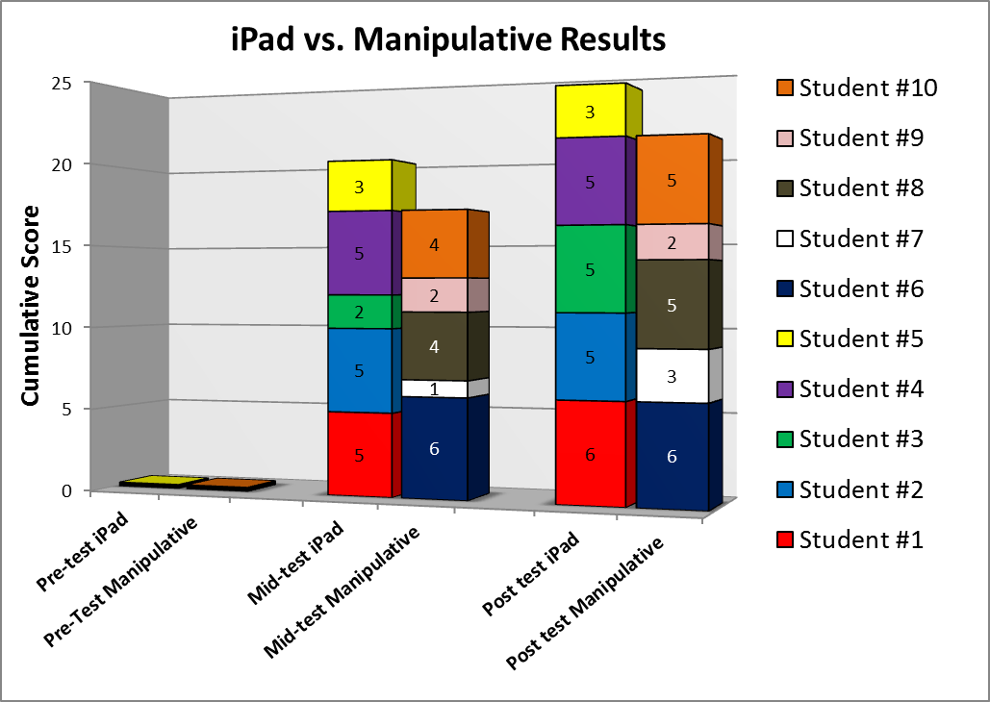**Findings and Implications**

Quantitative findings:

The quantitative data in the table above shows a slight trend towards better results with the iPads. Further testing with larger sample sizes of students to track trends would be needed to make any conclusion with a higher confidence level. Increased numbers of comparative tests between manipulatives and iPads with a small student sample size could also lead to conclusions with a higher confidence level.

Qualitative findings:

Before I began research I worried about whether a basically two-dimensional app could compete with three-dimensional learning. Could hands-on learning be replaced with “pointer finger on”, and would it be as good? I don’t feel worried in the same way that I did before I started this action research. Several moments in the research come to mind as instructive. In the post-test for symmetry, one student recalled with clarity the importance of the mirror image on the butterfly’s wings in her definition of symmetry. She said, “The C has to be facing this way, not that way, for it to be symmetrical.” Clearly, drawing the butterfly herself after seeing the model and particularly noticing a mistake in one of the “We Do’s” had been instructive to her. She remembered and retained it after only one exposure. On that same subject, symmetry, but in the iPad group, one student begged to play the iPad symmetry app for several days after it had been introduced. Clearly, he was excited about that new app and wanted to spend more time exploring symmetry. Isn’t that what we want from students?

That one experiment ended up resolving some of the doubts that were lurking in my mind. One student might “get it” from drawing a butterfly wing with symmetry. One student might “get it” from playing with an app. Another might need to see it presented both ways or even a third and fourth way before they finally “get it”. My job was to just keep providing exploration time and varied strategies with repetition of the basic concept until mastery was achieved. As I go forward with the implementation of iPads in my classroom, I think it will be important to guide iPad math exploration time so that children are being exposed to new concepts, to concepts with which they struggle, and also to be allowed to go back to concepts to reinforce them.

Conducting this research has helped me to clarify in my own mind that, while I am generally concerned with the amount of time that children spend daily plugged into technology, I do not need to see the implementation of iPads in my math hour as a zero sum game. I need to see it as just another tool in my toolkit that should remain diverse and flexible according to my students’ needs. I should make these determinations based on frequent checks for understanding, whether formal or informal, summative or formative.

I found that using a video rather than a written log was extremely helpful during the testing phase of the action research as I could capture so much more, and I had time to review the video afterwards to chart the categories of understanding that I was observing. In fact, I found that using video in all phases of the action research helped me to catch my own procedural errors and to see what was happening in all phases of the process more clearly.

In terms of guiding my instruction for the future, which is the goal of action research, this project was very instructive to me. I had been thinking about this topic, even worrying about it, long before I decided to pursue this Master’s program. When the iPads were initially rolled out at my school, I was a bit like a kid in the candy shop, probably enjoying a little too much time on the iPads. After all, they are as engaging to me as they are to the kids! In my second year working with the iPads, I had diverted more time back to working with hands-on manipulatives. Now, in my third year of implementing iPads in the kinder classroom and particularly into math instruction, I think this action research project has helped me to answer a very real question/concern that I had about their implementation, and I am a bit surprised at myself that I didn’t see it all along.

What I have found as a result of doing this action research project is that, as with any learning, the best question is not “which strategy is the most efficacious?”, but rather, “how many ways can I differentiate instruction to reach very different learner needs”? This might seem obvious, but it was not obvious to me as I worried about the efficacy of an iPad application in comparison to a hands-on environment. As with the quantitative findings, the qualitative findings are just a beginning. Further research over a longer period of time would be more instructive.

One concern I still have is with regards to the quality of collaboration in the classroom when working with iPads in comparison to hands-on projects. In this study, I did not attempt to measure the amount of collaboration and communication that occurred while the students played the math app, but that could be the topic of a future action research in my classroom. How much time do children spend collaborating and problem solving while working on an app as compared to working on a hands-on assignment or during project or problem-based learning? The iPad could certainly be a tool for use in those models of learning, but do children collaborate and communicate as much? From reviewing field log video footage I did notice more collaboration with the iPad apps than I thought was taking place. Children seemed to be constantly checking each other’s progress, sharing as they learned something new and very eager to help each other while using the apps. It would be interesting to get quantitative data on that subject.

Appendix A

Name:______________________________ PRE-TEST

Verbal Instructions:

“Put a circle around the pictures that show **symmetry**.”

C:\Users\kmoorehead\AppData\Local\Microsoft\Windows\Temporary Internet Files\Content.IE5\KMG9MZX4\MC900446140[1].wmf C:\Users\kmoorehead\AppData\Local\Microsoft\Windows\Temporary Internet Files\Content.IE5\L03A6JM8\MC900441409[1].wmf C:\Users\kmoorehead\AppData\Local\Microsoft\Windows\Temporary Internet Files\Content.IE5\UACO2Z40\MC900299463[1].wmf C:\Users\kmoorehead\AppData\Local\Microsoft\Windows\Temporary Internet Files\Content.IE5\P05VZBDK\MC900445096[1].wmf C:\Users\kmoorehead\AppData\Local\Microsoft\Windows\Temporary Internet Files\Content.IE5\KMG9MZX4\MC900240149[1].wmf

Appendix B

Name:______________________________ POST-TEST

Verbal Instructions:

“Put a circle around the pictures that show **symmetry**.”

C:\Users\kmoorehead\AppData\Local\Microsoft\Windows\Temporary Internet Files\Content.IE5\KMG9MZX4\MC900446140[1].wmf C:\Users\kmoorehead\AppData\Local\Microsoft\Windows\Temporary Internet Files\Content.IE5\L03A6JM8\MC900441409[1].wmf C:\Users\kmoorehead\AppData\Local\Microsoft\Windows\Temporary Internet Files\Content.IE5\UACO2Z40\MC900299463[1].wmf C:\Users\kmoorehead\AppData\Local\Microsoft\Windows\Temporary Internet Files\Content.IE5\P05VZBDK\MC900445096[1].wmf C:\Users\kmoorehead\AppData\Local\Microsoft\Windows\Temporary Internet Files\Content.IE5\KMG9MZX4\MC900240149[1].wmf

Appendix C

Student Sample: Symmetry

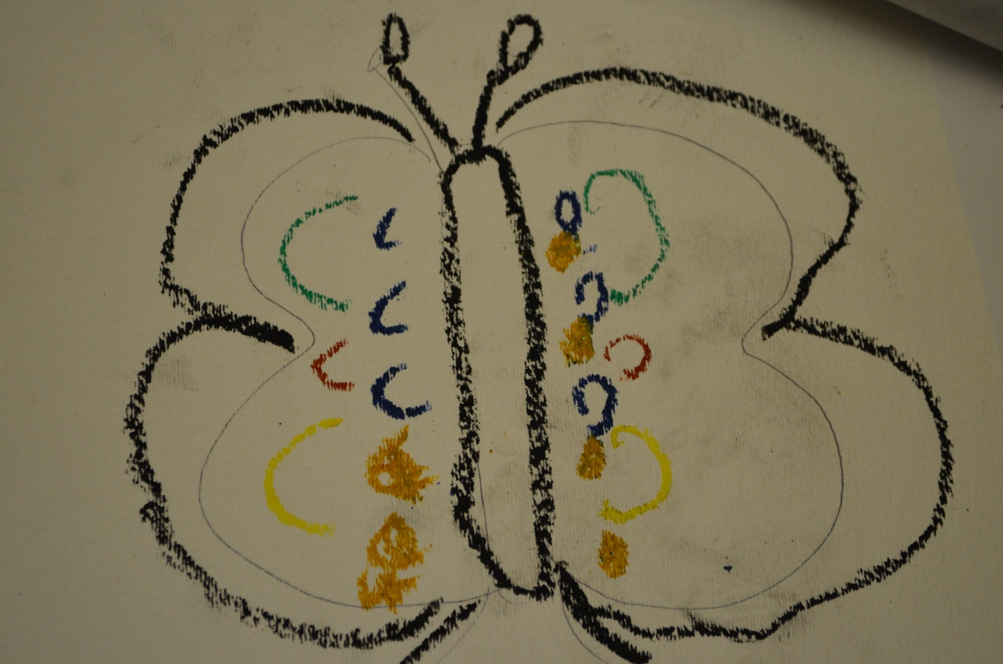

Appendix D

Script for verbal instructions on pre-test, mid-test and post-test in Mancala:

1. Do you know the name of this game?
2. Can you set up the board so we can play? (There should be four beads in each bin but not in the end cups.)
3. Ok, let’s play. You can go first. (Students should show evidence of picking up all beads in one bin, moving counter-clockwise, dropping only one bead in sequential bins, and skipping the Mancala point bin of their opponent.)
4. What happens now? (After student has finished their turn they should indicate that I take my turn.)
5. What happens now? (If student has made a strategy move and landed in their Mancala bin they should respond that they get to take another turn.)

References

Abilene Christian University. (2011, September 19). *ACU research sheds light on mobility in teaching, learning* [Web log post]. Retrieved from http://www.acu.edu/news/2011/110919-mobility-research.html

Bonnington, C. (2012, January 23). *IPad a solid education tool, study reports*. *CNN*. Retrieved from http://www.cnn.com/2012/01/23/tech/innovation/ipad-solid-education-tool/

Byrne, R. (2013, March). *A small collection of studies of iPad use in education* [Web log post]. Retrieved from http://ipadapps4school.com/2013/03/21/a-small-collection-of-studies-of-ipad-use-in-education/

Clements, D. H. (1999). Concrete manipulatives, concrete ideas. 45-60. Retrieved from http://www.didax.com/articles/concrete-manipulatives-concrete-ideas.cfm

Department of Education and Early Childhood Development. (2011, December). *Ipads for learning in their hands trial* [Scholarly project]. Retrieved from https://www.google.com/search?q=ipads+for+learning+in+their+hands+trial&rlz=1C1SNNT_enUS367US367&oq=iPads+for+learning+in+&aqs=chrome.2.69i57j0l5.8365j0j8&sourceid=chrome&espv=210&es_sm=93&ie=UTF-8

*GameDesk* [Scholarly project]. (n.d.). In *GameDesk*. Retrieved from http://gamedesk.org/project/motion-math-in-class/

Gertner, R. T. (2011, September 19). *The effects of multimedia technology on learning* [Scholarly project]. In *Abilene Christian University*. Retrieved from http://www.acu.edu/technology/mobilelearning/documents/research/effects-of-technology-on-learning.pdf

Haselton, T. (2013, March 3). TechnoBuffalo [Web log post]. Retrieved from http://www.technobuffalo.com/2013/03/03/apple-8-million-ipad-school/

Heinrich, P. (2013, July). *The iPad as a tool for education* [Scholarly project]. In *Naace*. Retrieved from http://www.naace.co.uk/publications/longfieldipadresearch

I & J Management Services. (2011, December). *IPads for learning In their hand trial* [Scholarly project]. In *IPads for Education*. Retrieved from http://www.ipadsforeducation.vic.edu.au/ipad-student-trial/lessons-learnt

International Schools and ICT [Web log post]. (n.d.). Retrieved from http://internationalschoolsandict.wordpress.com/2012/10/26/ipad-a-new-classroom-technology/

Math Solutions [Advertisement]. (2014). Retrieved from http://mathsolutions.com/

Mertler, C. A. (2009). Models of action research. In *Action research: Teachers as researchers in the classroom* (pp. 13-18). Los Angeles: Sage.

Muir, M. (2012, February 16). Confirmed: IPads Extend a Teacher’s Impact on Kindergarten Literacy | Multiple Pathways [Web log post]. Retrieved from http://multiplepathways.wordpress.com/2012/02/16/confirmed-ipads-extend-a-teachers-impact-on-kindergarten-literacy/

Reich, J. (2012, February 17). Justin Reich [Web log post]. Retrieved from http://www.edtechresearcher.com/2012/02/are-ipads-making-a-significant-difference-findings-from-auburn-maine/

Riconsente, M. (2012, March 1). *Mobile learning game improves 5th graders’ fractions knowledge and attitudes* (Rep.). Retrieved from https://gse-ldt.stanford.edu/news/mobile-learning-game-improves-5th-graders%E2%80%99-knowledge-and-attitudes-about-fractions

Risconcente, M. M. (2013, July 1). Results From a Controlled Study of the iPad Fractions Game Motion Math. *Results From a Controlled Study of the IPad Fractions Game Motion Math*. doi: 10.1177/1555412013496894

Rose, F. (n.d.). *IPad pilot program @ Oberlin College* [Scholarly project]. In *IPad Pilot Program @ Oberlin College*. Retrieved from https://sites.google.com/a/oberlin.edu/ipad-pilot-program/

United States, National Center for Education Statistics, Institute of Education Services. (1993, September). *Public School Kindergarten Teachers' Views on Children's Readiness for School*. Retrieved from http://nces.ed.gov/surveys/frss/publications/93410/index.asp?sectionid=5

Wainright, A. (2013, February 18). SecurEdge blog: Security and mobility simplified. [Web log post]. Retrieved from http://www.securedgenetworks.com/secure-edge-networks-blog/bid/86775/8-Studies-Show-iPads-in-the-Classroom-Improve-Education

Walsh, K. (2012, July 8). Study Finds Benefits in Use of iPad as an Educational Tool. *Emerging Education Technology RSS*. Retrieved from http://www.emergingedtech.com/2012/07/study-finds-benefits-in-use-of-ipad-as-educational-tool/